Hit Trax Statistics Definitions

Pitch: Speed of Incoming Pitch
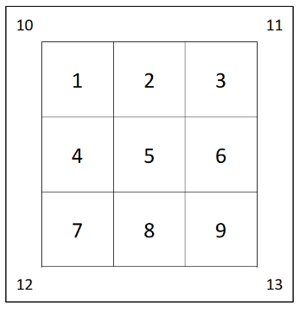
Incoming pitch speed. If this value is less than 25-28 mph, then it is from front toss and if it is higher than 50 mph, this is off a pitching machine.
Strike Zone:
The specified area that the pitch was made contact at. There are 13, here is a photo of where each zone is; 9 boxes inside the zone, 4 outside the zone.
P. Type: Pitch Type
This will always be logged as OT, for overhand throw.
Velo: Exit Velocity
How fast the ball is coming off the bat; generally, the harder the better.
LA: Launch Angle
Launch angle of ball after contact. Maximizing exit velocity at an optimal launch angle is a key component. This is essentially a by-product of the swing, bat path, and timing. Generally, the optimal trajectory to maximize production sits somewhere between 10-25 degrees depending on bat speed.
Dist: Distance
Distance that the ball is hit.
Res: Result
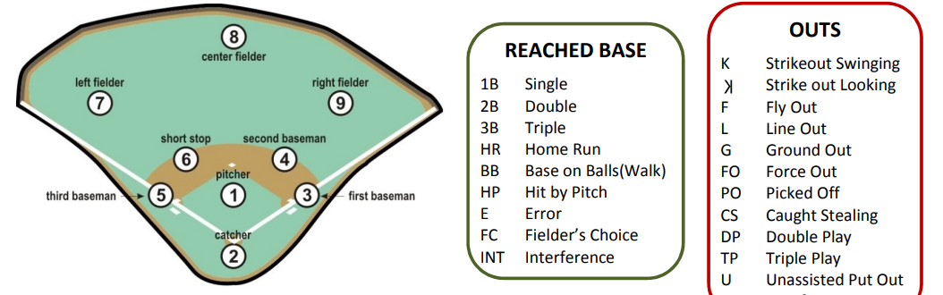
Result of the hit ball; consists of two parts. The first is the outcome, second is where the ball is hit to. Here is what each letter and number mean.

Type: Type of Hit
FB = Flyball
LD = Linedrive
GB = Groundball

Horiz. Angle: Horizontal Angle
Angle between the resulted batted ball angle and the plane at which the pitch came in.
Strike Zone Bottom:
Bottom of strike zone measurement. This will always be 20.3.
Strike Zone Top:
Top of strike zone measurement. This will always be 39.4.
Strike Zone Width:
The width of the strike zone. This will always be 17.
Vertical Distance:
How high into the air (Y-Axis) the ball traveled post contact.
Horizontal Distance:
How far the ball travelled horizontally (X-Axis) the ball traveled post contact.
POI X: Point of Impact in X- Axis
Illustrates where along the swing path the bat/ball impact is made on horizontal plane.
POI Y: Point of Impact in Y-Axis
Where along the swing path the bat/ball impact is made in vertical plane.
POI Z: Point of Impact in Z-Axis
Where along the swing path the bat/ball impact is made on z-plane.
Spray Chart X:
A spray chart is a visualization tool to see the spread of where a player is hitting balls to. This is the x value of the location on the field from a hit.
Spray Chart Z:
Measurement on the z-plane that corresponds to a location on the field from a hit.
Fielded X:
Measurement of where the ball is fielded by a computerized person on hittrax software in the x-direction.
Fielded Z:
Measurement of where the ball is fielded by a computerized person on hittrax software in the z-direction.
Tag: User can input a tag to identify session. Usually this will either be blank, say front toss/ft, or machine.
AVG: Batting Average
Number of hits divided by number of at bats.
SLG: Slugging Average
This measures how many bases a batter averages per at bat. The number of total bases reached divided by the total number of at bats.
AvgLA: Average Launch Angle
Average value of launch angles from a session.
HHA: Hard Hit Average
Hit Trax identifies hard hit balls as any ball hit within 90% of the player’s maximum exit velocity. This is then the total number of hard hit balls divided by total number of balls hit.
LHP: Line Drive + Hard Hit Percentage
The value of the total number of line drives and hits that were categorized as a hard hit divided by the total number of at bats.
LD%: Line Drive Percentage
The number of line drives an individual hits as a percentage value. Line drives are categorized by having a launch angle between 10-25 degrees.

GB%: Ground Ball Percentage
The number of ground balls an individual hits as a percentage value. Ground balls are categorized by a launch angle below 10 degrees.

FB%: Fly Ball Percentage
The number of flyballs an individual hits as a percentage value.

AvgVel: Average Exit Velocity
Evaluates how consistently the athlete hits the ball hard. Simply, this is the average exit velocity of the athlete. In an ideal world, the average should be as close to maximum velocity as possible.

MaxVel: Maximum Exit Velocity
The hardest hit ball that the athlete achieves. Can symbolize raw power and the ability when hitting the ball without any regard for the ball’s trajectory.

MaxDist: Maximum Distance
The farthest hit ball that an individual produces in a swing.

EBH: Extra Base Hits
The number of extra base hits. An extra base hit is any hit logged that is not a single so a double, triple, or home run.

